CS2043 Design Project

System Overview

Version 1.0

Sunday, April 7th, 2019

Team 2

Contributors: **Coby Pugh,** Colton Scott, Joshua Burgess,Thomas Daley

How to Use the System

This guide will serve as a short overview on how to use the system.

There are 3 configuration files that the system requires: the text-based transcript_analyser.config file, which provides definitions for file paths, the naming convention of the transcripts being processed, and other variables that can be defined by a simple line of text.

The second required file is the course_equivalence.xlsx file, which provides a way to store courses that are equivalent. A definition is store in a column, and each equivalent course is listed in a new row, in that column.

The third required file is the course_areas.xlsx file, which provides a way to store courses in an “area” such as Math, or Science. Each area occupies a column. The title is in the first row, and every course in that area is in a new row in that column.

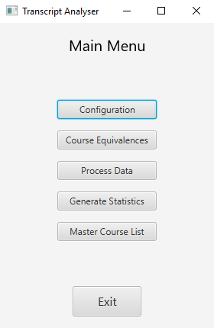

Figure 1. Main Menu.

When first launching the program, the main menu will appear. There are five options available:

* **Configuration** allows the user to view the text configuration file.
* **Course Equivalences** provides access to the course equivalence configuration
* **Process Data** allows the user to process student transcripts.
* **Generate Statistics** allows the user to generate statistics based on the set of transcripts that have been processed.
* **Master Course List** provides a list of all courses that are in the set of transcripts that have been processed.

Only the first three options will actually be useful until the transcripts are processed.

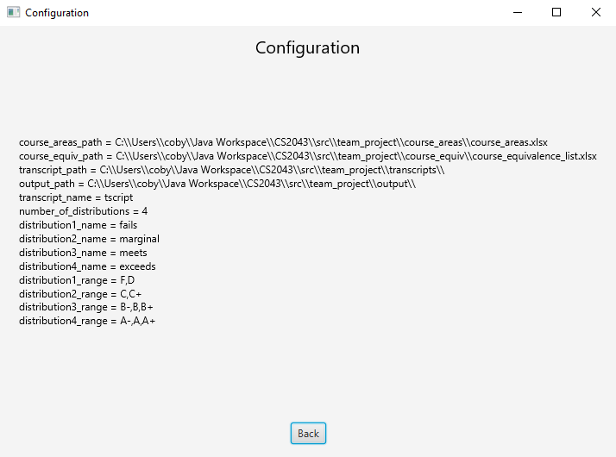

Figure 2. Configuration Viewer.

The configuration viewer allows the user to view which configuration settings have been loaded by the system.

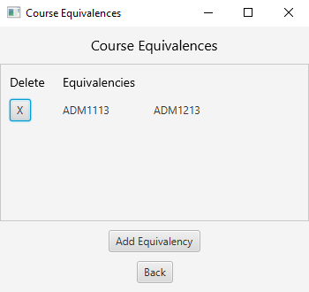

Figure 3. Course Equivalence Menu.

The Course Equivalence menu allows the user to view course equivalences. The user is also able to add new Equivalences, or remove equivalences, directly from the GUI. Of course, they can still modify the course_equivalence.xlsx file while the system is not in use.

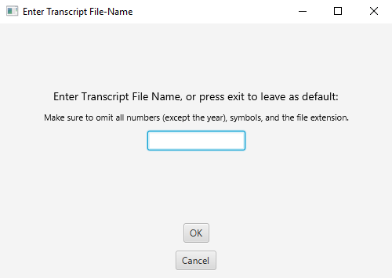

Figure 4. Change the Transcript File-Name.

When the user is ready to process their transcripts (which should be in a .txt file) they will be prompted to enter the file name, omitting numbers (except the year), symbols, and the file extension. For example, if the name of transcript files will be 2015EE_1.txt, the user should enter 2015EE.

It is important to note that the end of the file name will be _<number>.txt, and there is no way for the user to change that.

If the file name has already been set externally in the transcript_analyser.config file, the user is safe to click cancel, and transcripts with that file name will be processed.

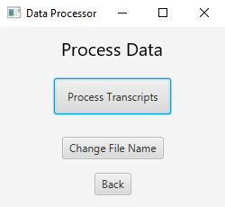

Figure 5. Data Processing Menu.

Once the file name has been set, it is now time to press the button that says Process Transcripts. The file name can be changed again if there is another set of transcripts with a different file name to be processed.

Please note that changing the file name in this window will not save it to the configuration file.

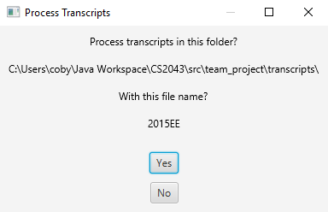

Figure 6. Process Transcripts Confirmation.

When the user presses the “Process Transcripts” button, this prompt will appear. It will show the user the file path of the folder where the transcripts are located, and the name of the transcripts that are about to be processed. The user can press no and go back and change the file name, or the file path, or they can press ok. A window will appear as soon as the processing has terminated, and they will be redirected back to the main menu.

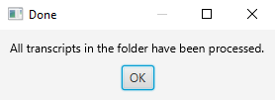

Figure 7. Transcripts have been processed.

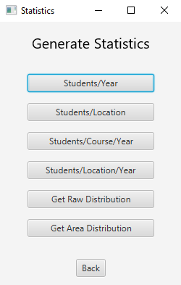

Figure 8. Statistics Menu.

There are 4 statistics to be generated, and the user is also able to generate the raw distribution for marks, which will show the grading distribution for every course, or the area distribution for marks, which will show the distribution for courses across defined course areas.

When the user selects a statistic to generate, it will send the output to the file output.xlsx in the specified output folder. If the file has already been initialized by the system, the existing file will be appended to.

Upon selecting a statistic, the user will be prompted to enter the required details, and they will be redirected back to the statistics menu when the task has terminated.

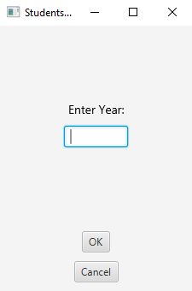

Figure 9. Students Per Year Statistic.

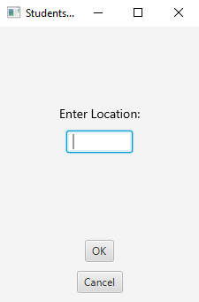

Figure 10. Students Per Location Statistic.

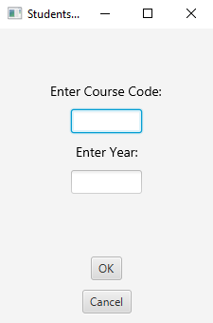

Figure 11. Students Per Course Per Year Statistic.

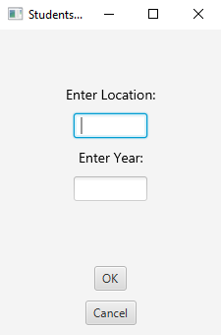

Figure 12. Students Per Location Per Year Statistic.